For this experiment, I exposed one petri dish to the bacteria in the air in my house and the other petri dish to the bacteria on my hand. Unfortunately, I had to redo this experiment three times since the first two times, the agar melted upon exposure to heat. The first two times, the agar was made at home, following the teacher’s instructions. Since this method did not work for me, I had to use an already-made agar mixture for the third attempt in order to see some bacterial colonies to complete the experiment. Unfortunately, since I only had a day and a half for the third attempt, no visible colonies were seen on my samples by the time this experiment was due.

After searching online for the types of microbes that would normally be found on hands, I saw that there are two categories of bacteria that normally inhibit the surface of the skin on hands: resident and transient (1). Resident bacteria include types such as *Staphylococcus epidermidis, S. hominis, propionibacteria*, *corynebacteria*, dermobacteria, and micrococci. *Pityrosporum* (*Malassezia*) spp is a common fungi that can also be classified as a type of resident skin flora. Transient skin flora includes *S. aureus*, Gram-negative bacilli, and yeast.

*Staphylococcus epidermidis* and *Staphylococcus aureus* are both harmless unless they enter the body through an open wound or medical incision (2). If this is the case, then these bacteria can cause an infection called staph infection. MRSA, a type of staph infection, is resistant to antibiotics and therefore can pose a great health threat. *Staphylococcus epidermidis* are usually 1-2 mm wide and white (5) while *Staphylococcus aureus* can be found in large, golden-yellow colonies (6).*Corynebacteria* are mostly associated with acne leasions. In agar culture, they can be seen as yellowish-white with granular appearance and convex (4). *S. hominis* is known for producing compounds associated with body odor (3). Althrough normally harmless, it can become a threat in patients with weakened immune systems. In agar culture, it can be identified as circular, 4-4.5 mm in diameter, and yellow-orange pigmented.

The picture seen below is of an 8 year-old’s handprint in a petri dish. It allows us to see some of the microbial colonies normally found on hands (7). The white swirly colony on the bottom right is hypothesized to be *Bacillus* genuswhile the colored colonies can be yeast, *Serratia*, or *Micrococcus*. The smaller white circular colonies are thought to be *Staphylococcus* genus.

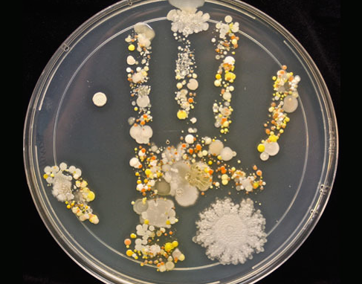

1. <http://www.ncbi.nlm.nih.gov/books/NBK144001/>
2. <http://www.livestrong.com/article/201160-types-of-bacteria-on-childrens-hands/>
3. <https://en.wikipedia.org/wiki/Staphylococcus_hominis>
4. <https://en.wikipedia.org/wiki/Corynebacterium>
5. <https://en.wikipedia.org/wiki/Staphylococcus_epidermidis>
6. <https://en.wikipedia.org/wiki/Staphylococcus_aureus>
7. <http://www.upworthy.com/an-8-year-olds-bacteria-filled-handprint-is-the-coolest-thing-ive-seen-all-week>